Bulky items such as:
Household and garden furniture, mattresses, electrical appliances, etc.
Contact Municipality for collection free of charge.

Call phone 3906 for “Allo Mairies”
- This is the single telephone number for the removal of bulky items
- Make an appointment prior to drop-off
- Give your name and French telephone number
- Some operators of this service speak English but not all, there is no dedicated line for English speakers
- Removal of bulky items is only done on TUESDAY MORNINGS
- Bulky items must be deposited the evening before, therefore on MONDAYS FROM 19h.
If the phone number 3906 does not work probably – you can contact the municipality`s service by email:
3906@nicecotedazur.org. Enter the subject “Dechets encombrants (Le Broc)” + inform about items it concerns. You will
Then receive confirmation by mail of the agreement. Drop off Monday evening for collection on Tuesday morning at the drop-off location.
The drop-off location Le Broc local recycling place, which can be found just outside Le Broc 100 metres from Residence les Sources.
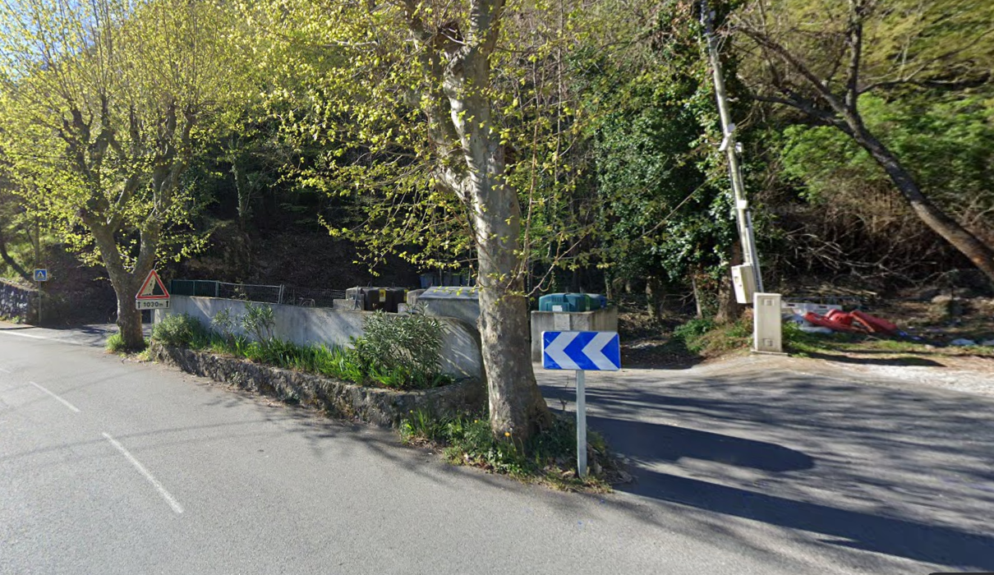
- Accepted: household and garden furniture, sofas, box springs, mattresses, household appliances (volume 3x3m maximum per appointment – ​​length 2m maximum)
- Not accepted: glass, glazing, clothing, rubble, paint cans, dishes, trinkets, chemicals

