Bulky items: Household and garden furniture, mattresses, electrical appliances, etc.
Contact Municipality for collection free of charge.

French mobile dial 3906 for “Allo Mairies”
Foreign mobile dial 04.97.13.20.00 and ask for “Allo Mairies”
Monday – Friday 08.00 - 18.00 /Saturday 08.30-12.00
- Make an appointment prior to dropping off
- Give your name and French telephone number
- Some operators of this service speak English but not all, there is no dedicated line for English speakers
- Removal of bulky items is only done on TUESDAY MORNINGS
- Bulky items must be deposited the evening before, therefore on MONDAYS FROM 19h.

If the phone numbers do not work probably – you can contact the municipality`s service by email:
3906@nicecotedazur.org. Enter the subject “Dechets encombrants (Le Broc)” + inform about items it concerns. You will
then receive confirmation by mail of the agreement.

Drop off Monday evening for collection on Tuesday morning at the drop-off location.
The drop-off location Le Broc is the local recycling place, which can be found just outside Le Broc 100 meters from Residence les Sources.
The alternative address which must be agreed is the place with containers on the left side before entrence Residence Les Sources, 281, Route de Nice.
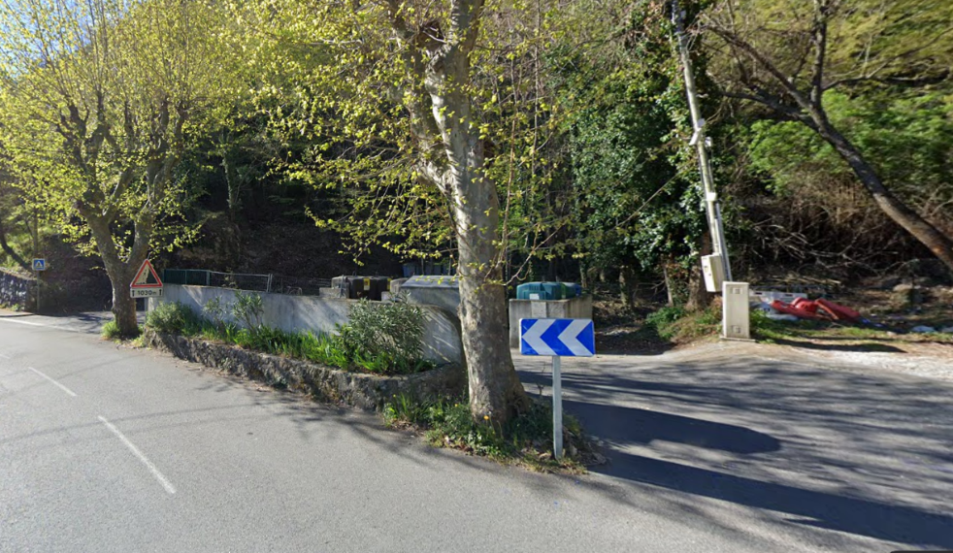
- Accepted: household and garden furniture, sofas, box springs, mattresses, household appliances (volume 3x3m maximum per appointment – ​​length 2m maximum)
- Not accepted: glass, glazing, clothing, rubble, paint cans, dishes, trinkets, chemicals

